Costa Rican Bulk Rock Compositions

Julie M. Coulombe

4/1/2020

Switching gears and taking a look at the bulk composition of the rocks themselves.

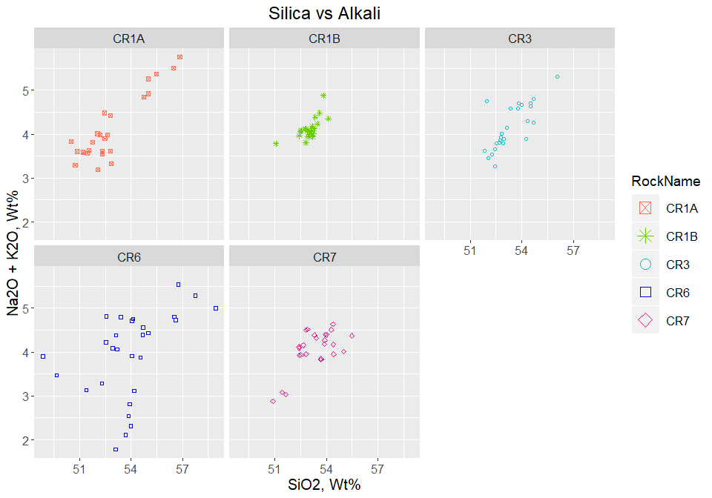

## `geom_smooth()` using method = 'loess' and formula 'y ~ x'

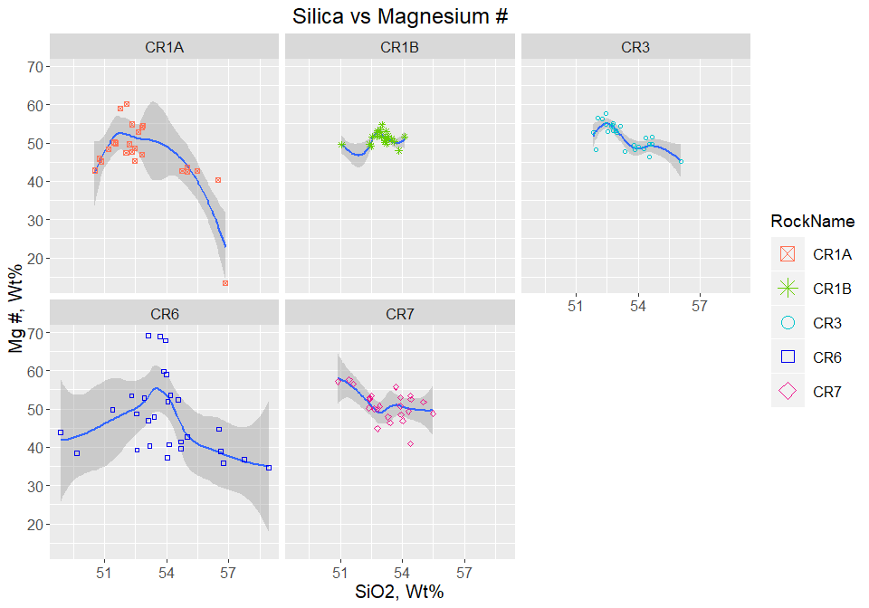

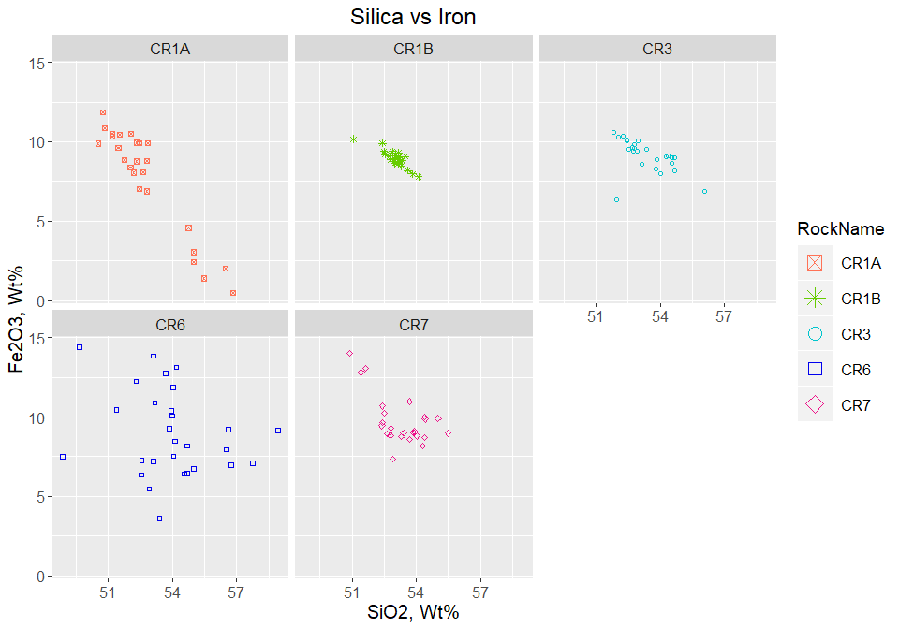

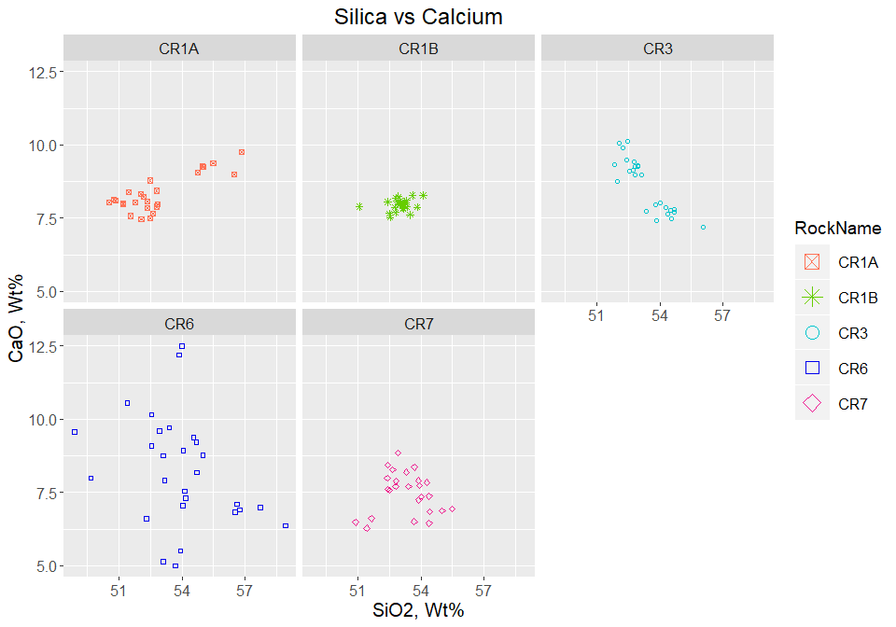

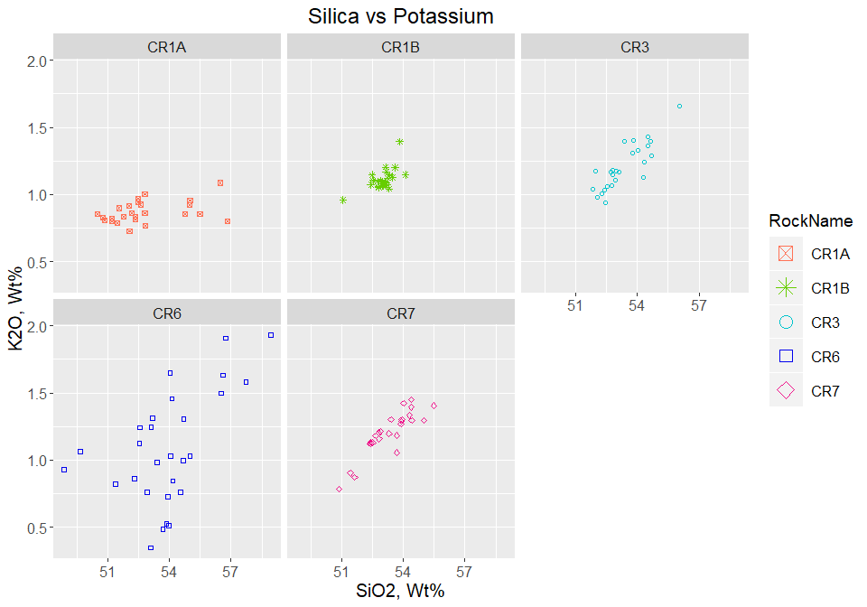

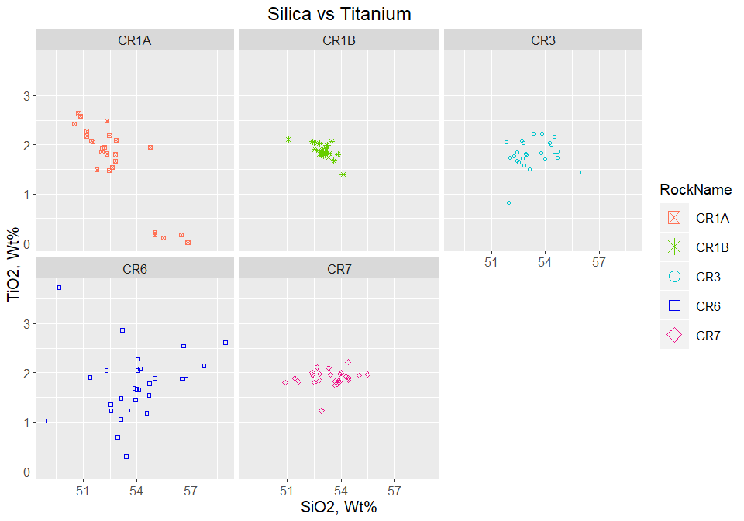

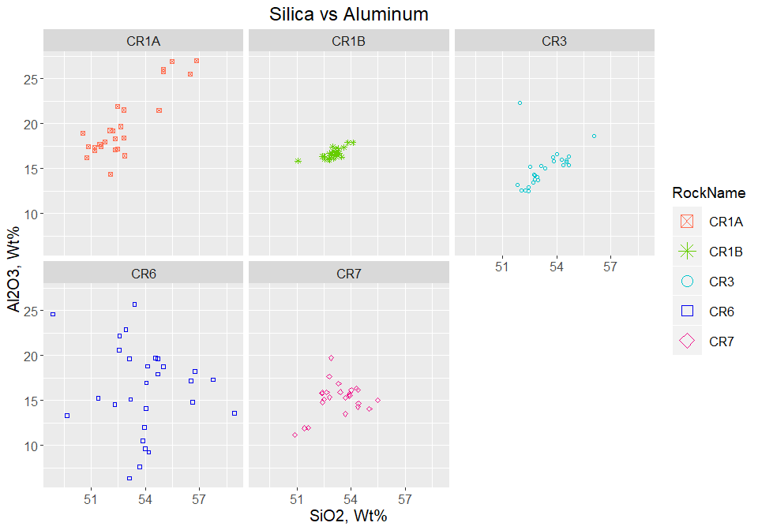

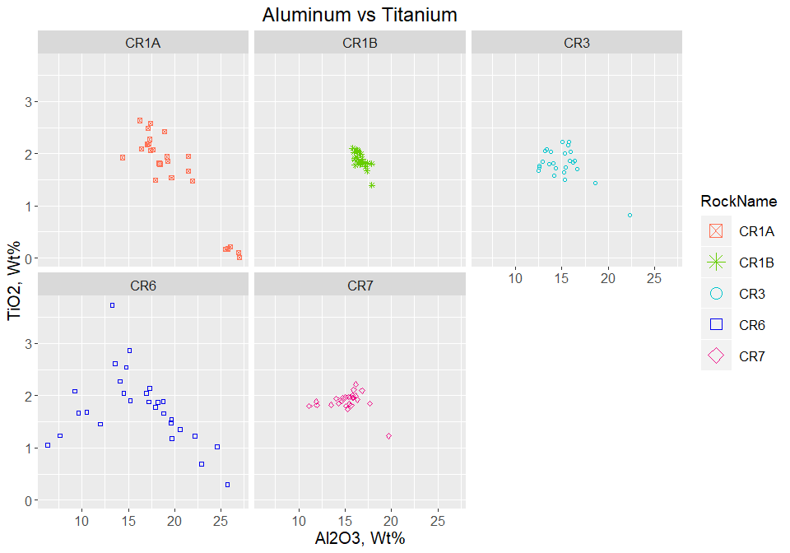

Plot Alkali by Rock Name - Bulk Composition 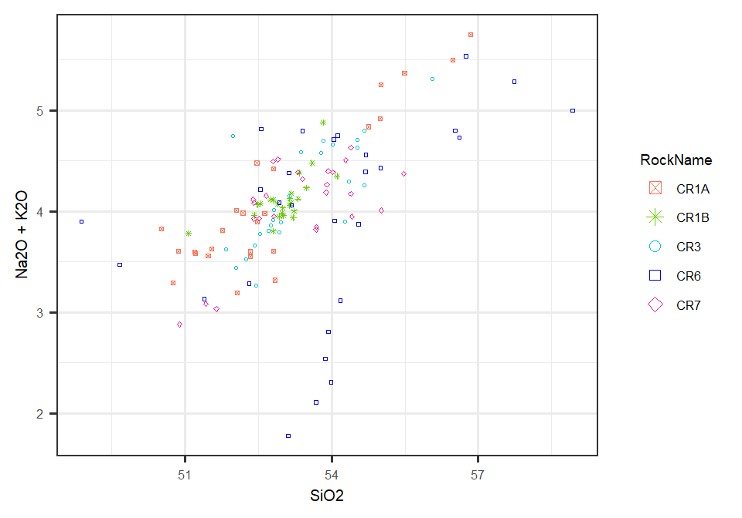

Overlay Alkali Plot on TAS Diagram 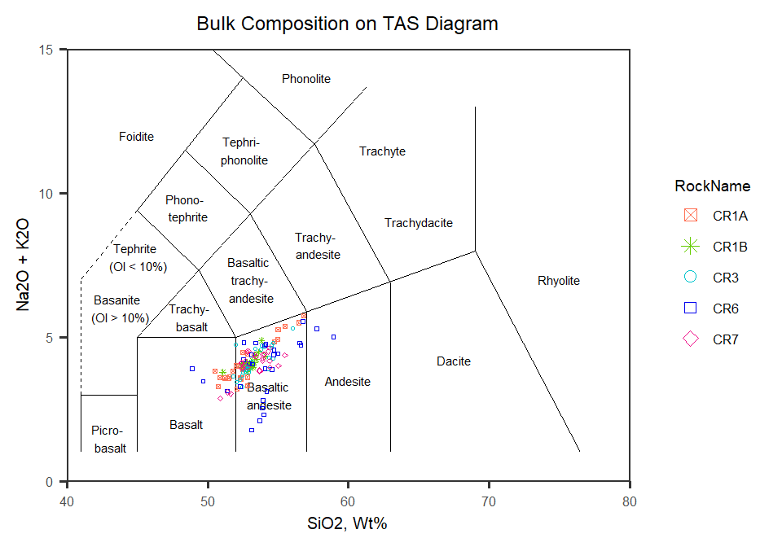

Now to look at plots of all rocks together

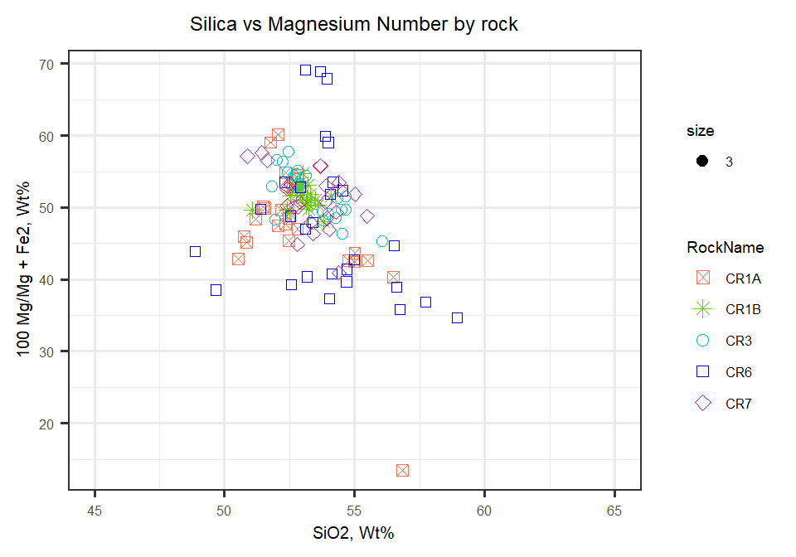

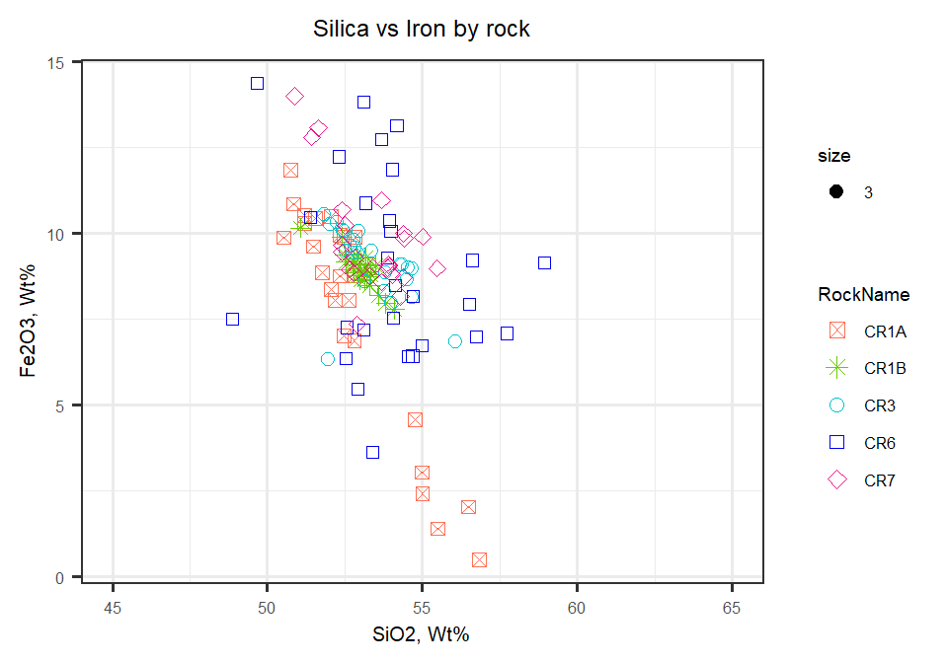

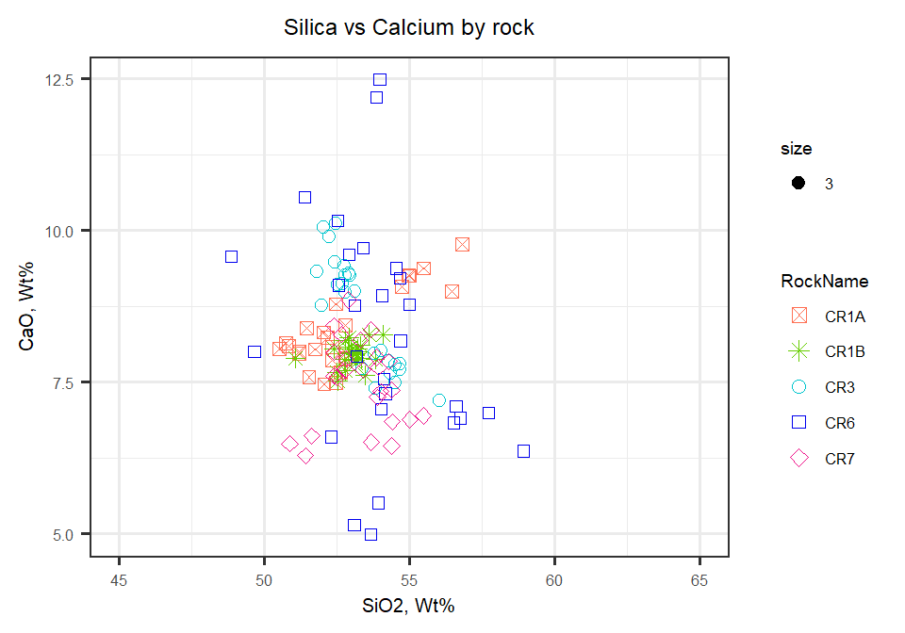

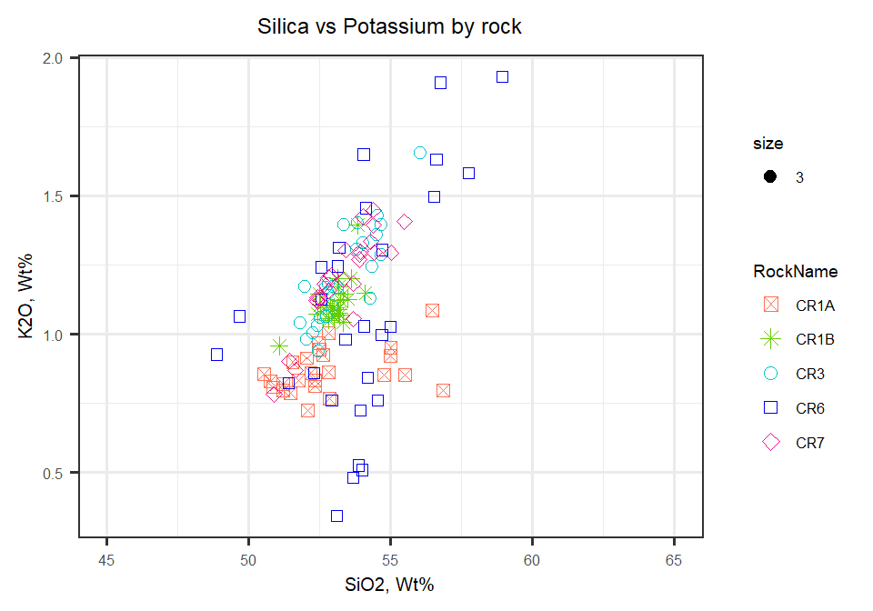

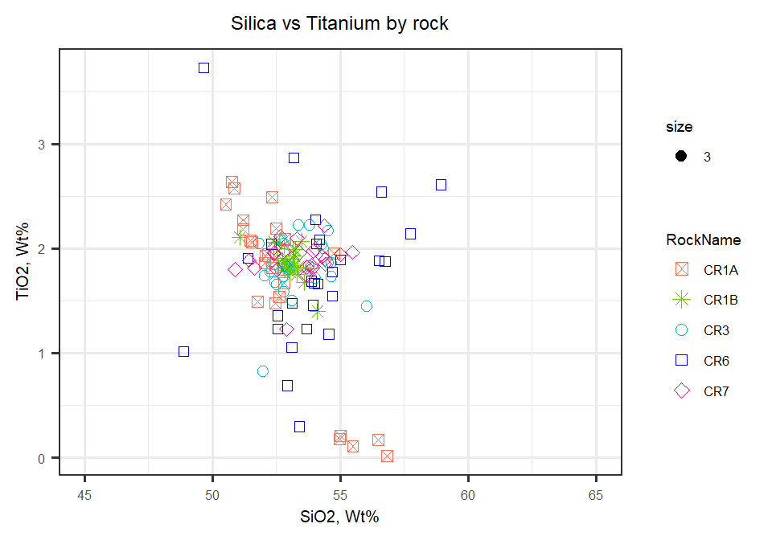

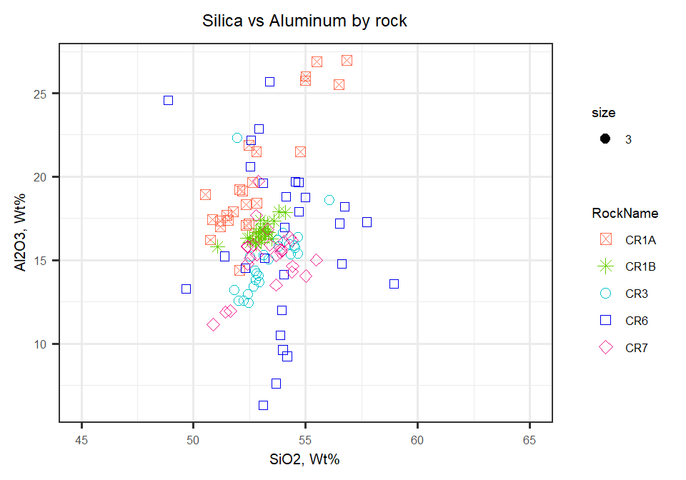

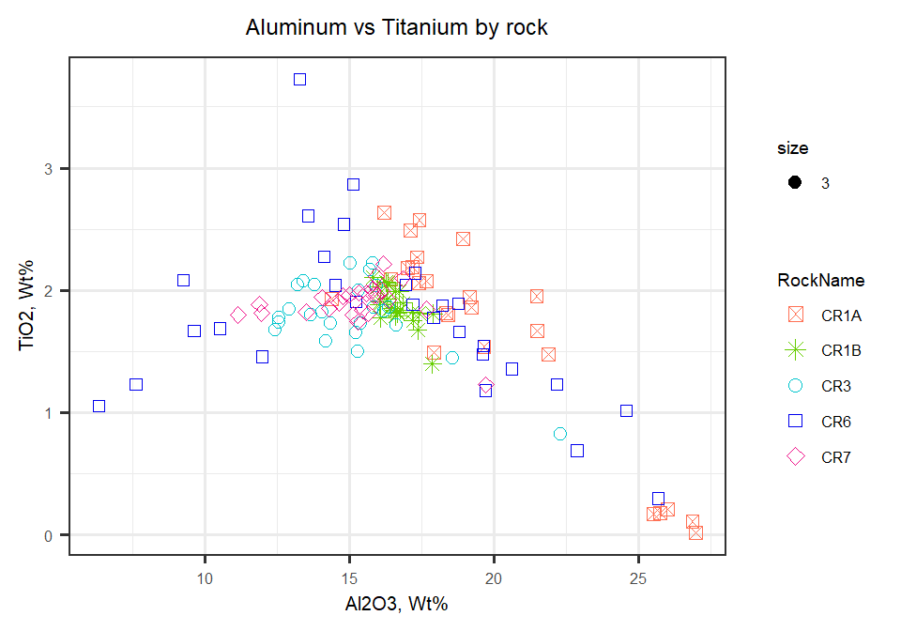

cat(“\pagebreak”)

Pull all above plots into figure for publishing

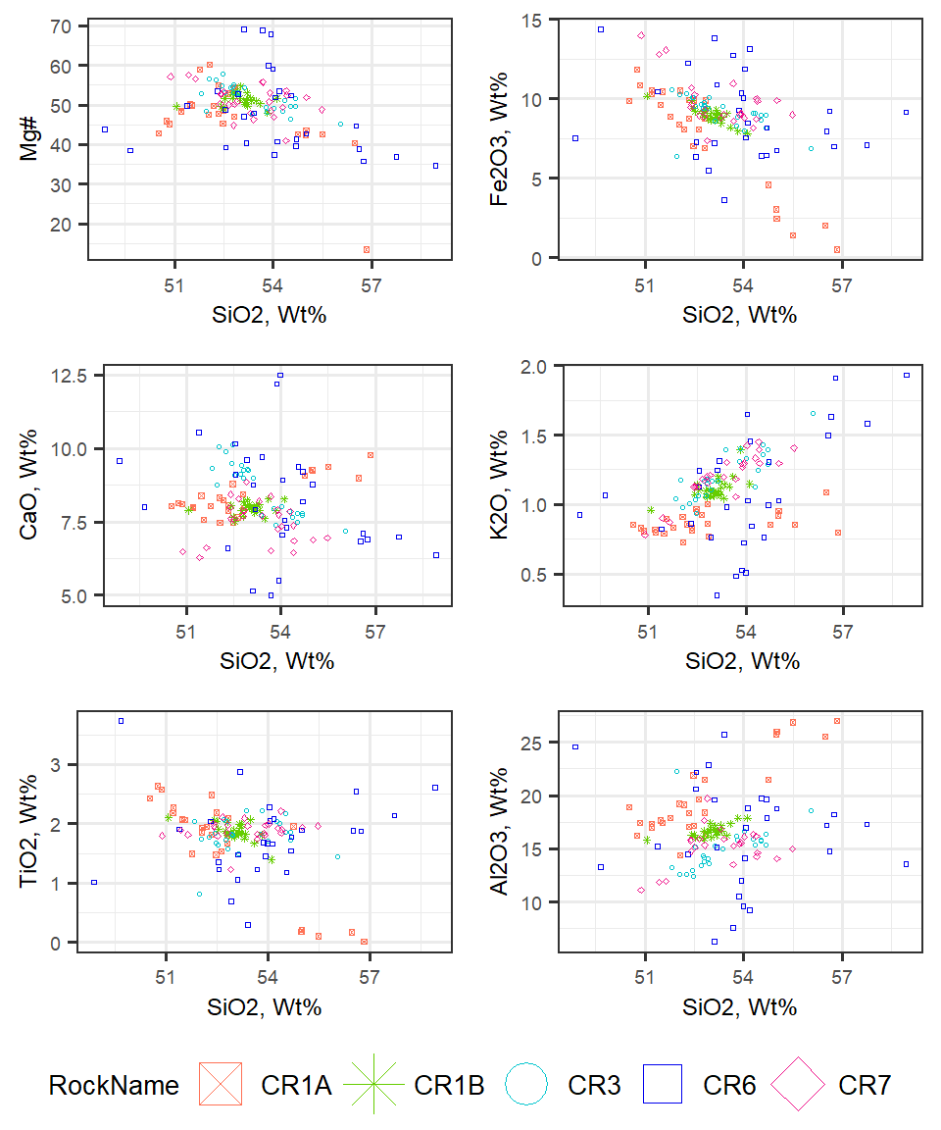

Now to compare CR1A to CR1B Harker Diagrams  
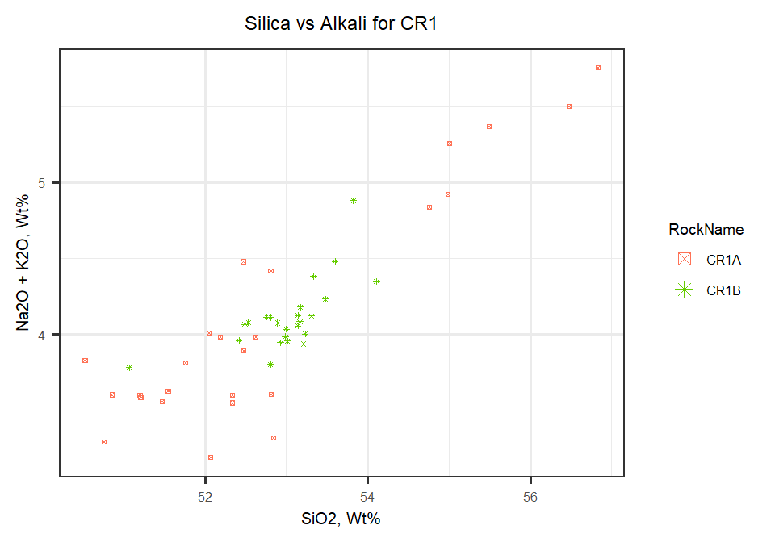

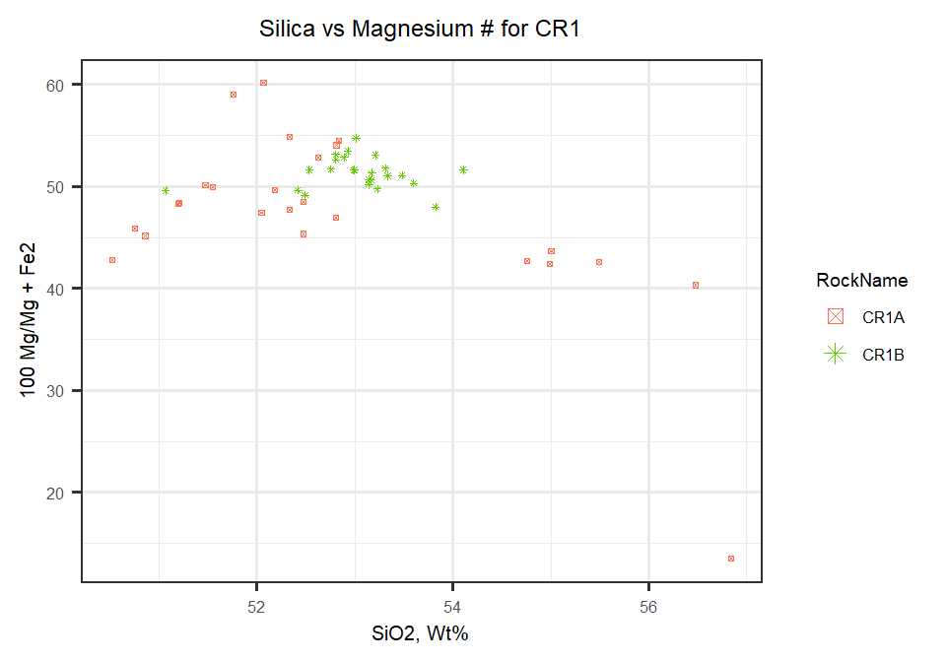

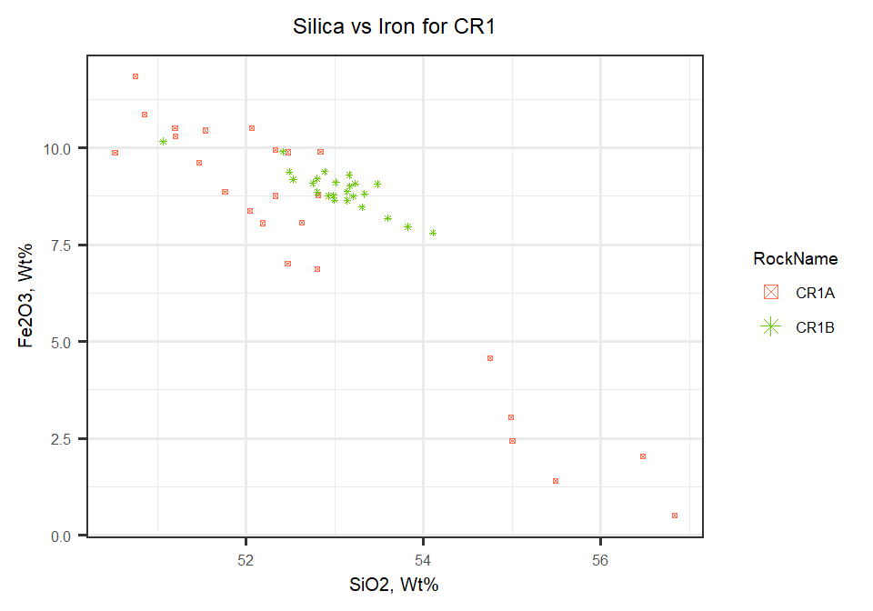

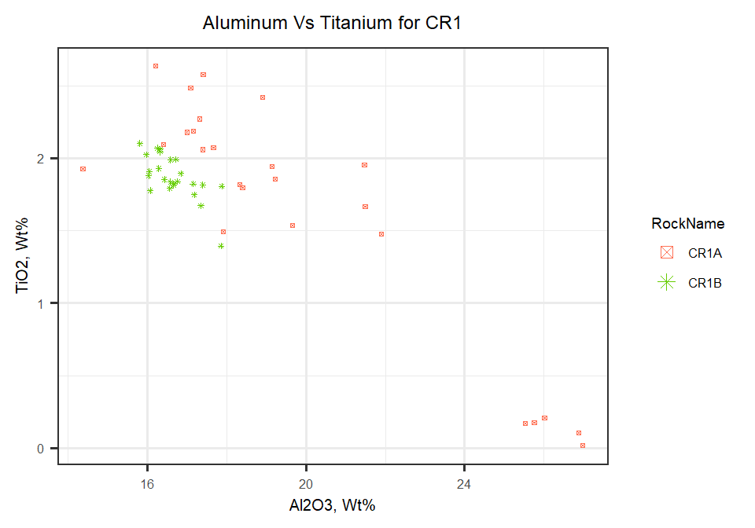

Taking a look at comparing CR2A to CR2B in Bulk Composition (bulk data for CR2 not yet available)

Table indicating mean averages for elements by rock

|  |  |  |  |  |  |  |
| --- | --- | --- | --- | --- | --- | --- |
| **RockName** | **P2O5** | **SiO2** | **TiO2** | **Al2O3** | **Cr** | **MgO** |
| CR1A | 0.302 | 52.8 | 1.64 | 19.8 | 0.0311 | 4.32 |
| CR1B | 0.349 | 53 | 1.87 | 16.7 | 0.0264 | 5.29 |
| CR3 | 0.346 | 53.3 | 1.81 | 15.1 | 0.0285 | 5.59 |
| CR6 | 0.301 | 53.9 | 1.76 | 16.3 | 0.0322 | 5.33 |
| CR7 | 0.349 | 53.3 | 1.9 | 15.2 | 0.0261 | 5.88 |
| **RockName** | **CaO** | **MnO** | **Fe2O3** | **Na2O** | **K2O** | **S** | **Total** |
| CR1A | 8.33 | 0.11 | 7.7 | 3.24 | 0.868 | 0.00635 | 99.3 |
| CR1B | 7.95 | 0.147 | 8.93 | 3 | 1.11 | 0.00881 | 98.8 |
| CR3 | 8.62 | 0.162 | 9.12 | 2.95 | 1.21 | 0.00736 | 98.9 |
| CR6 | 8.24 | 0.158 | 8.95 | 2.87 | 1.09 | 0.00902 | 99.1 |
| CR7 | 7.48 | 0.168 | 9.73 | 2.86 | 1.2 | 0.00784 | 98.8 |